KMA MEMBERSHIP 2026

Name and address as you want it on mailing label

________________________________________________________________________________
________________________________________

Print list all household members if family membership
______________________________________________________________________________
______________________________________________________________________________

Type of membership- circle one
New Renewal
Single 1 year--------$37.00 Single 3 year--------$97.00
Family 1 year-------$45.00 Family 3 year-------$120.00
Club 1 year----------$45.00 Club 3 year----------$120.00
Single Lifetime------$375.00 Family Lifetime-----$525.00
TOTAL DUES $__________
[Paiding by cash check check # credit]

Paying by check: mail to: Betty Jo Chapman, Treasurer 515 N 9th, Fredonia Ks 66736
Paying by Credit Card: call Rose Burns, Secretary— 620-724-3109

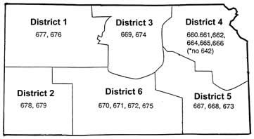
Kansas Districts Out of State members are District O

