Location: From the Hwy 47 & Hwy 169 Jct. north of Thayer, Ks, go approx. 5 miles south to 60th Road and Hwy 169, then approx. 1/2 miles east on north side of road.
From Hwy 400 & Hwy 169 Jct. go approx. 8.7 mi. to 60th Rd and Hwy 169.
For more information call Betty Jo Chapman: 620-378-3285

Shooting from 9 a.m.-4 p.m. No relays after 3 pm.
Cost will be:
Rifle: $10, Pistol: $5; Hawk/Knife: $2
Shooting will consist of:
Rifle will be 15 shots at metal targets, most consecutive hits will be tie breaker.
Pistol will be 10 shots at metal targets, most consecutive hits will be tie breaker.
Hawk will be 5 throws on a wood block, most consecutive hits will be tie breaker.
Prizes and medals will be awarded
Categories will be:
Men,s Rifle Men’s Pistol Women’s Rifle Wonen’s Pistol
Youth Rifle Hawk/Knife Throw
KMA AND ALL NMRLA RULES APPLY
Load facing down range Load from bag Use separate powder measure
DO NOT LOAD FROM FLASK No slings Cap and Prime on firing line only
Open sights Patched balls No visual aids on glasses
Primitive dress not required Do not need to be a KMA Member to shoot
Youth: 15 & under will be accompanied by an adult
Parking available
Range Master has final say
If you bring your pet, PLEASE have them on a leash at all times.
Camping Available: (primitive or modern) (no RV hook ups available) firewood provided, bring your own water
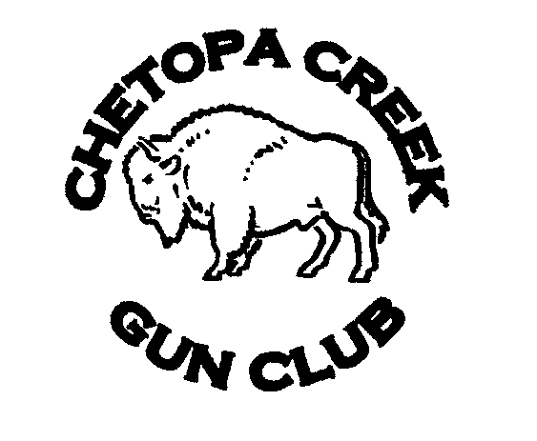
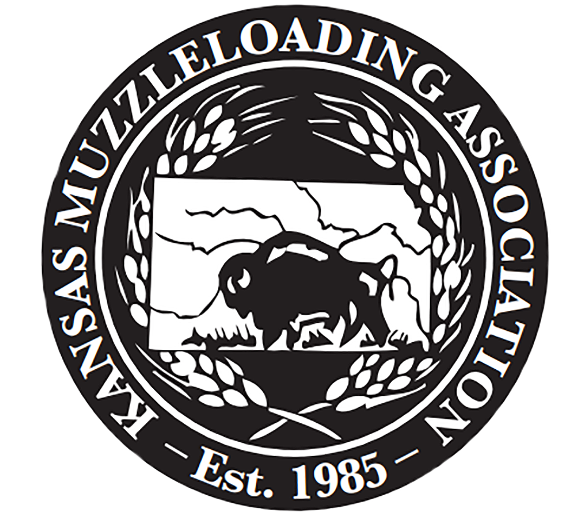

Kansas Muzzleloading Association

State Muzzleloading Rifle Shoot

hosted by

Chetopa Creek Gun Club

April 17-19, 2026
at our range southeast of Thayer, KS

