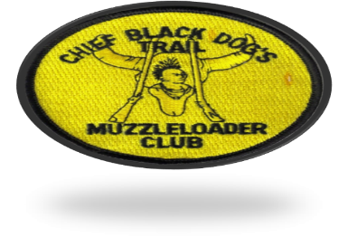
CAMPGROUND LOCATED 1.7 MILES NORTH OF OSWEGO, KS
CHIEF BLACK DOG’S MUZZLELOADER CLUB
SPRING RENDEZVOUS
APRIL 26-28, 2024
OSWEGO KANSAS
WALLACE ROAD TO 14000 ROAD
TURN RIGHT GO STRAIGHT THROUGH THE CENTER GATE
FROM PARSONS GO 8 MILES EAST ON 400 FROM THE 59 AND 400 OVERPASS. TURN RIGHT ONTO WALLACE ROAD AND GO ABOUT 11 MILES SOUTH TO 14000 ROAD. TURN LEFT GO THROUGH THE MIDDLE GATE TO CAMPGROUND.
FROM THE 69 AND 400 JCT. GO WEST 25 MILES TO WALLACE ROAD. TURN LEFT GO ABOUT 11 MILES SOUTH TO 14000 ROAD. TURN LEFT AND GO THROUGH THE MIDDLE GATE TO THE CAMPGROUND

NO ILLEGAL DRUGS ON PREMISES. VIOLATORS WILL BE TOLD TO LEAVE.
SOME WOOD. BRING YOUR OWN WATER.

SATURDAY NIGHT SUPPER IS POTLUCK. PLEASE BRING MAIN DISH OR DESSERT
SUNDAY MORNING BREAKFAST OF BISCUITS AND GRAVY PROVIDED.
Ending times mean NO entries after the ending time.
Minimum $5.00 blanket prize
RIFLE SHOOT $10.00 – 9 AM- -3:30 PM PISTOL SHOOT $5.00---10 AM-2 PM
BOW SHOOT $2.00---2 PM HAWK AND KNIFE THROW $2.00—10AM-2PM
TRADE GUN SHOOT AT 3:00 PM
TARGETS MUST BE TURNED IN BY 4:00 PM.

PRIMITIVE DRESS REQUIRED TO SHOOT NO VISIBLE JEANS OR TENNIS SHOES
SOME LOANER CLOTHES WILL BE AVAILABLE.
KMA AND NMLRA RANGE RULES
JUNIORS (15 AND UNDER) MUST BE ACCOMPANIED BY ADULT
LOAD FACING DOWN RANGE LOAD FROM BAG ONLY
OPEN IRON SIGHTS PATCHED BALLS NO VISUAL AIDS ON GLASSES
USE SEPARATE POWDER MEASURE DO NOT LOAD FROM HORN OR FLASK.
NO DRINKING NO SMOKING NO ILLEGAL DRUGS
ON THE FIRING LINE
• MOST CONSECUTIVE HITS WILL BE TIE BREAKER.
RANGE OFFICER HAS FINAL SAY
EARLY SET UP CALL ONE OF THE FOLLOWING
DOUG PULLIAM 620-249-9880 JERRY SLOAN 620-778-0431
ROSE BURNS 620-724-3109 KELLY PULLIAM 620-249-9883
RYAN MILLER 316-680-2226

